**Task 2**

**Name : Youssef Ahmed Hany**

Exercise 1:

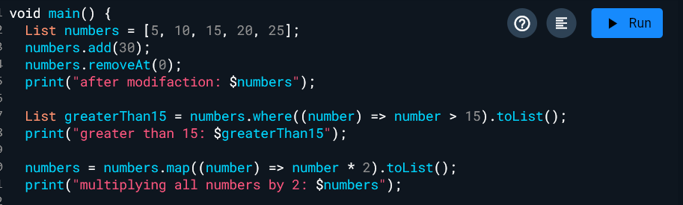

Exercise 2:

Exercise 3:

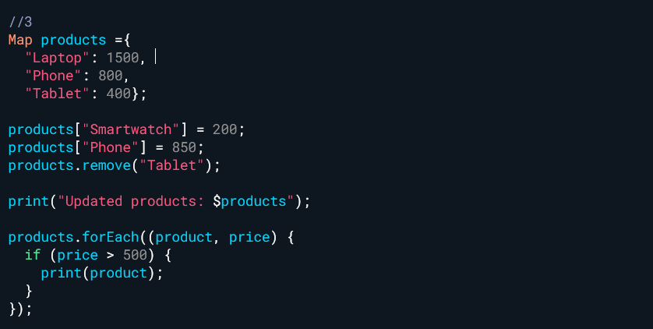

Exercise 4:

Exercise 5:

Exercise 6:

Exercise 7:

Exercise 8:

Exercise 9:

Exercise 10:

Exercise 11:

**Output:**

